Record sales thanks to heat pumps and efficiency technologies

- Sales rise to 2.5 billion euros – dynamic development in the EU
- Growth in core segments of electric heat pumps and gas-fired condensing boilers
- Satisfactory start to 2019

Remscheid, 23 May 2019 – The Remscheid-based heating, ventilation and air-conditioning technology specialist Vaillant Group increased its sales by 6 per cent in the 2018 financial year, reaching 2.5 billion euros. This means that the company recorded its highest revenue in history. International sales reached a share of over 80 per cent. “Despite the difficult economic environment, particularly outside Europe, the company showed profitable growth and improved its competitive position in important markets,” says Dr.-Ing. Norbert Schiedeck, CEO of the Vaillant Group, summing up the development of the family-owned company for the last financial year. Both business with high-efficiency gas-fired condensing technology and business with electric heat pumps contributed to the significant increase in revenue and a highly satisfactory development of earnings. Regional growth was mainly focused on EU markets in 2018.

Dynamic development in the EU
In the European sales regions, the Vaillant Group recorded sales increases between 3.5 and 12 per cent. In particular, business in the UK, Southern Europe and Eastern European EU countries developed positively in the course of the year. This development was supported by an expansion of the customer base among installers and a broader range of both service and training offerings for Vaillant partners. On the technological side, the essential growth drivers were efficient gas-fired condensing boilers and heat pumps. In 2019 the Remscheid-based heating technology specialist will continue to expand its heat pump range, including the launch of appliances which are based on a natural, environment-friendly coolant.

The most important markets of the Vaillant Group outside Europe developed less strongly in 2018 than in the previous year. In Turkey, the demand went down, while there was also a negative currency development in the form of a sustained devaluation of the Turkish lira against the euro. Moreover, for the first time in over ten years, the Chinese heating technology market experienced stagnation. Nevertheless, the Vaillant Group was able to consolidate its position as the leading European supplier in the Chinese market, with a slight increase in sales volume in relation to the general market trend. Furthermore, the company continued to strengthen its sales channels and partner networks.

Larger market share in heat pumps
The heat pump business developed extremely positive for the Vaillant Group, with sales 20 per cent higher than the year before. In nearly all major core markets Vaillant’s heat pump business grew more vigorously than the overall market, which generally moved ahead at good pace. Also, during the second half of 2018, the company launched numerous new heat pump models and increased its production capacities. Thanks to this extended portfolio, the Vaillant Group is a full-range supplier of heat pumps, with solutions to satisfy all the needs of its customers and all building requirements. In 2019, the company is launching a range of heat pump models with a natural and particularly environment-friendly coolant for the first time. These devices are also suitable for modernising existing properties. Until recently the use of heat pumps has mainly concentrated on the new-build sector. The availability of this technology for modernisation is opening further sales potential in the future.

Growth in efficient gas-fired condensing technology
With a sales increase of around 9 per cent, the Vaillant Group continued to be the European market leader in wall-hung gas boilers in 2018. The business with efficient gas-fired condensing technology therefore continued to be a major pillar of the Vaillant Group’s business development, and this technology is making a vital contribution to the energy transition in the building technology sector. By replacing outmoded equipment with state-of-the-art gas-fired condensing boilers, it is possible to save substantial amounts of CO₂ as well as energy costs. Moreover, the proportion of gas from renewable resources is set to rise further in the years to come. Efficient and economical heat generation with condensing technology based on “green” gas can be a crucial step in reaching climate protection targets in the building technology sector.

Strategic focus of the Vaillant Group on further growth
The concentration on condensing technology and heat pumps reflects the strategic position of the family-owned company from Remscheid. “Heat pumps and gas-fired condensing technology will continue to be core technologies of the heating market until 2030 and beyond. To continue our profitable growth, we will keep expanding our international leadership in gas-fired condensing technology. At the same time, we are aiming for a leading role in heat pumps in Europe. Our sales structures, product portfolio and manufacturing capacities are geared towards further growth. In addition, we will focus on the development of digital services for installers and end customers,” says Dr.-Ing. Norbert Schiedeck, as he explains important aspects of the corporate strategy.

Satisfactory start to the 2019 financial year
Set against the background of a continually difficult market environment, the company was satisfied with the start to the 2019 financial year. Adjusted for exchange rate effects, the sales figures for the first quarter in 2019 have been at the same level as in the previous year. While business within Europe generally remained stable, the market situation in Turkey – which had already been difficult – deteriorated even further. In China, on the other hand, the Vaillant Group benefited from the rise in market dynamics at the beginning of the year.

The Vaillant Group is an internationally active company based in Remscheid, Germany, which operates in the fields of heating, ventilation and air-conditioning technology. As one of the global market and technology leaders, the Vaillant Group develops and manufactures customised products, systems and services to provide a comfortable living environment. Its product portfolio ranges from efficient heating devices based on conventional energy sources to system solutions for using renewable energy. In the financial year 2018, the company, which has been family-owned since its foundation in 1874, generated sales of around 2.5 billion euros with its workforce of about 13,000.

------------------------------------------------------------------------------------------------------
Contact

Dr Jens Wichtermann Phone: +49 2191 18-2754
Group Director Communication, Mobile: +49 175 2951810

Sustainability & Government Relations E-mail: jens.wichtermann@vaillant-group.com

Vaillant Group Web: www.vaillant-group.com
42850 Remscheid, Germany

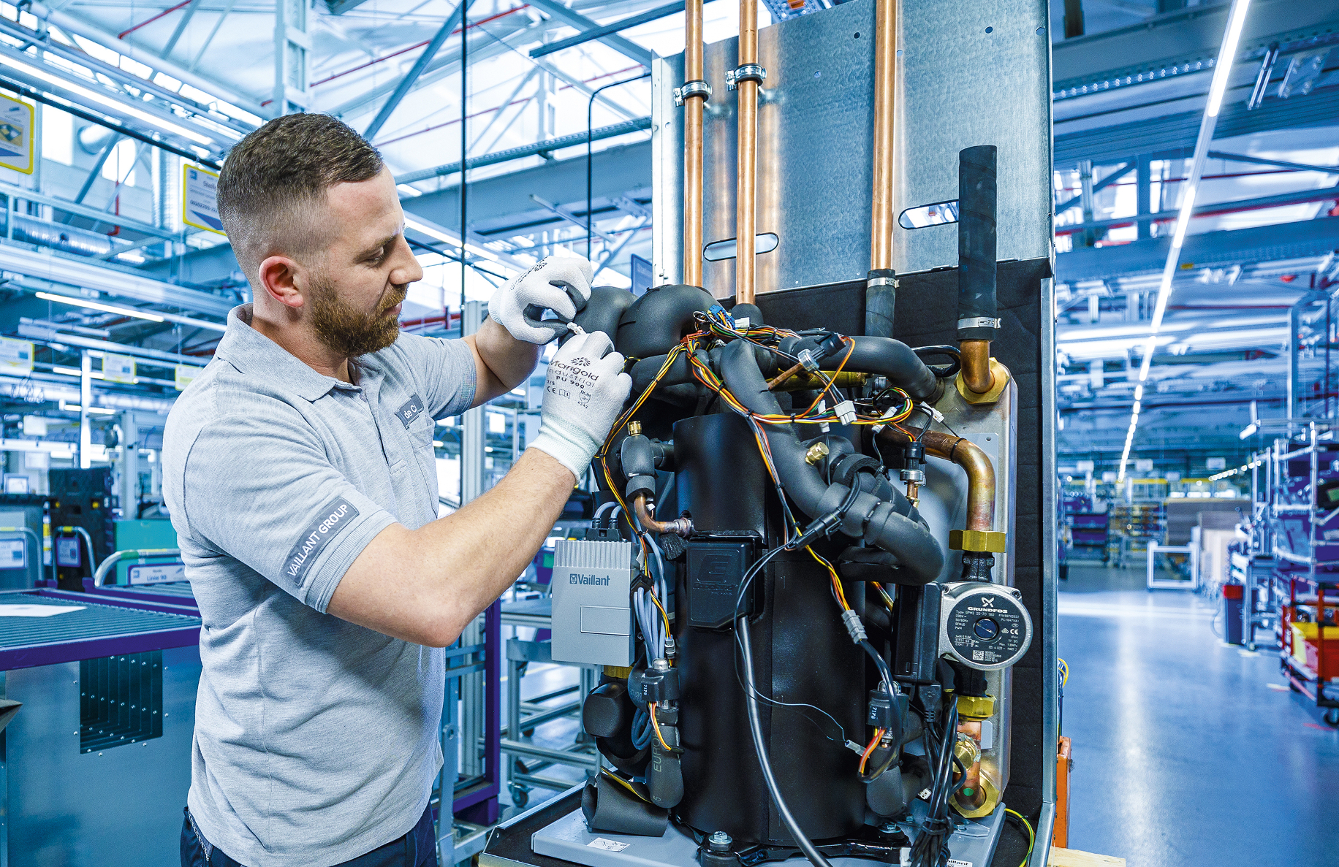

Caption: Vaillant heat pump production in Remscheid, Germany. Heat pumps and efficiency technologies helped the Vaillant Group to achieve a record sales figure of 2.5 billion euros – the highest in its corporate history.

Image: Vaillant Group

