Vaillant Group holds house-raising ceremony for its Research and Development Centre

Remscheid, 12 October 2018 – Today, the Vaillant Group held the house-raising ceremony for its Remscheid-based Research and Development Centre. With numerous municipal representatives, firms involved in the construction and additional guests in attendance, the three Vaillant Group Managing Directors drove the final nail symbolically into a roof beam.

The house-raising ceremony marks the completion of the building shell. The construction of the bridge, connecting the Research and Development Centre to the adjacent manufacturing plant, is also finished. At present, interior works and the installation of the comprehensive building technology are under way.

In its final form, the Research and Development Centre will consist of three elements: two office blocks and one test centre. The test centre will house more than 230 test rigs – including 40 test rigs just for heat pumps. All features considered, the Vaillant Group invests €54 million to raise at its headquarters in Remscheid one of the most modern research and development sites in the entire German state of North Rhine-Westphalia.

Attention was paid to implement a comprehensive energy concept. The heating technology specialist uses all the industrial waste heat of the test rigs for heating the building, resulting in a significant reduction of energy consumption and CO₂ emissions.

The Vaillant Group is an internationally active company based in Remscheid, Germany, which operates in the fields of heating, ventilation and air-conditioning technology. As one of the global market and technology leaders, the Vaillant Group develops and manufactures customised products, systems and services to provide a comfortable living environment. Its product portfolio ranges from efficient heating devices based on conventional energy sources to system solutions for using renewable energy. In the financial year 2017, the company, which has been family-owned since its foundation in 1874, generated sales of around 2.4 billion euros with its workforce of over 13,000.

------------------------------------------------------------------------------------------------------
Contact

Dr Jens Wichtermann Phone: 02191 18-2754
Director Group Communications, Mobile: 0175 2951810

Sustainability Management & Politics E-mail: jens.wichtermann@vaillant-group.com

Vaillant Group Web: www.vaillant-group.com
42850 Remscheid, Germany

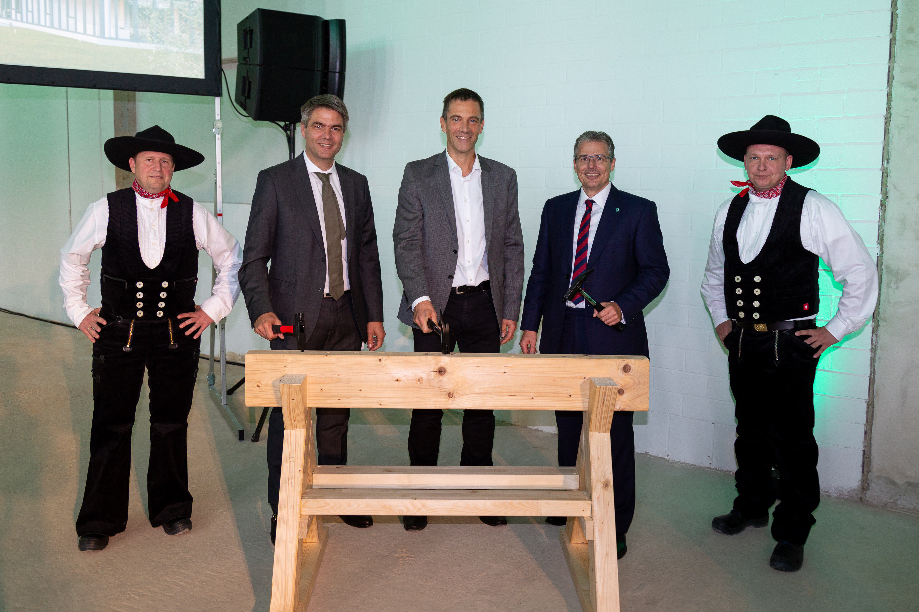

Caption: House-raising ceremony at the Vaillant Group: Symbolically, Managing Directors Dr Andree Groos (2nd from left), Dr.-Ing. Norbert Schiedeck (middle) and Dr Stefan Borchers (2nd from right) drove the final nail into a roof beam of the new Research and Development Centre.

Picture source: Vaillant Group

