Dr.-Ing. Norbert Schiedeck new Chairman of the
Vaillant Group Management Board

Remscheid, 3 May 2018 – The Partners’ Board of Vaillant GmbH has appointed Dr.-Ing. Norbert Schiedeck Chairman of the company’s Management Board with effect from 1 May 2018. He succeeds Dr Carsten Voigtländer, who left the company at the end of March 2018 and whose portfolio Dr.-Ing. Schiedeck had already been taken over on an interim basis since April 2018. As Chairman of the Management Board he is responsible for the corporate strategy, the expansion of the heat pump business, IT and various central departments. Until the position will be filled, Dr.-Ing. Schiedeck also remains in charge of his previous tasks as Managing Director Technology. In this function he has been responsible since 2014 for among other things the departments Development, Production, Purchasing and Quality.

The responsibility in the Management Board for the Sales, Marketing and Service division remains with Dr Andree Groos. Dr Stefan Borchers is responsible as Managing Director since the beginning of 2018 for the division Finance and Services.

The Vaillant Group is an internationally active company based in Remscheid, Germany, which operates in the fields of heating, ventilation and air-conditioning technology. As one of the global market and technology leaders, the Vaillant Group develops and manufactures customised products, systems and services to provide a comfortable living environment. Its product portfolio ranges from efficient heating devices based on conventional energy sources to system solutions for using renewable energy. In the financial year 2016, the company, which has been family-owned since its foundation in 1874, generated sales of around 2.4 billion euros with its workforce of over 12,000.

------------------------------------------------------------------------------------------------------
Contact

Dr Jens Wichtermann Phone: 02191 18-2754
Director Group Communications, Mobile: 0175 2951810

Sustainability Management & Politics E-mail: jens.wichtermann@vaillant-group.com

Vaillant Group Web: www.vaillant-group.com
42850 Remscheid, Germany

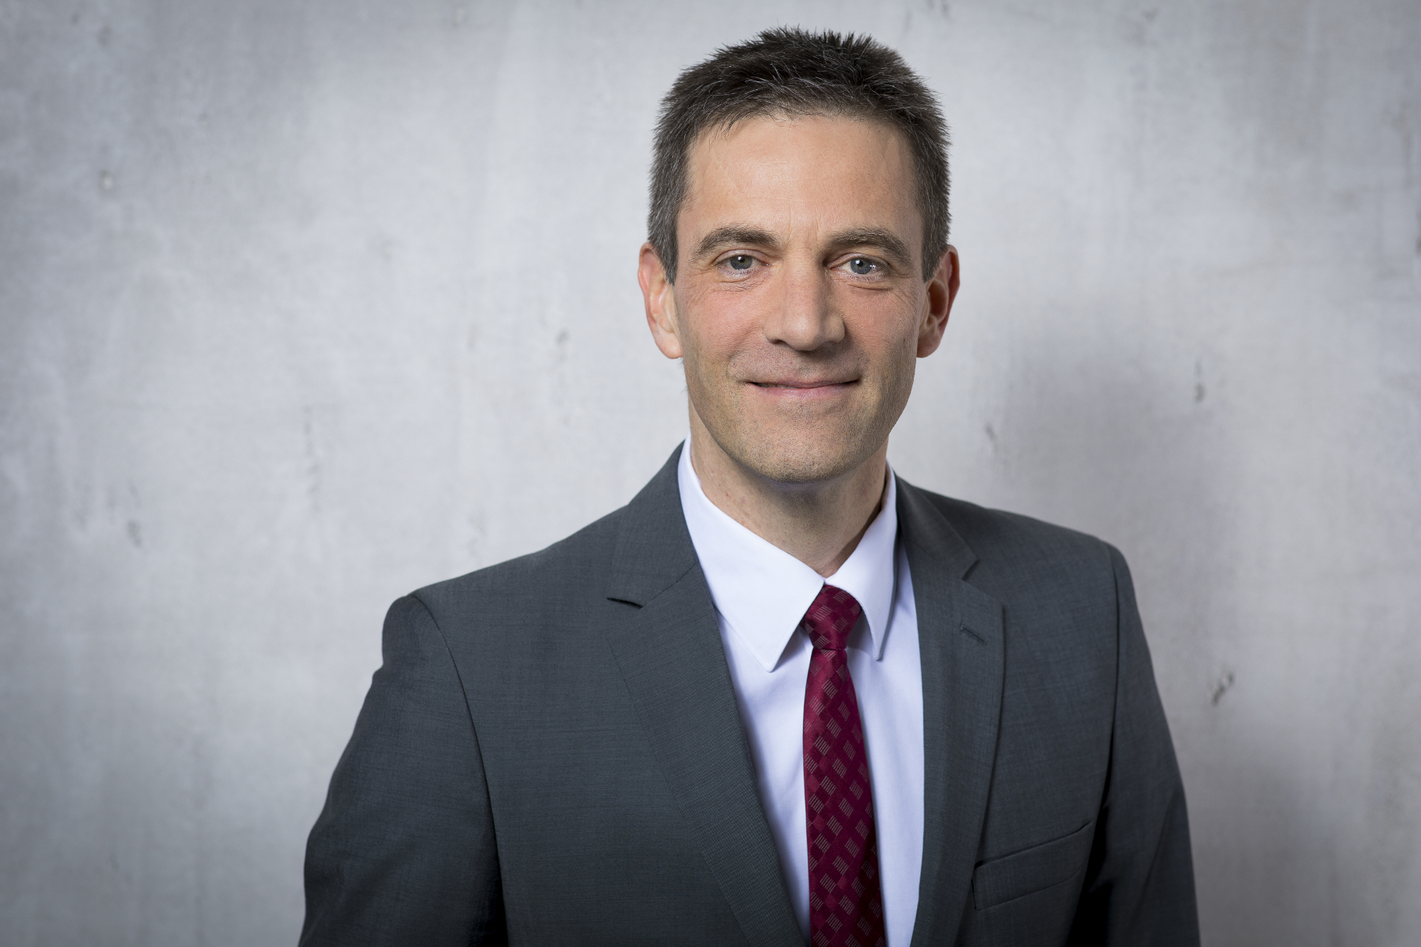

Caption:
The Partners’ Board of Vaillant GmbH has appointed Dr.-Ing. Norbert Schiedeck Chairman of the company’s Management Board with effect from 1 May 2018.

Image: Vaillant Group

