World Climate Conference at the Vaillant Group

- UN Climate Change Conference attendees welcomed to Remscheid
- Efficient heating technology essential to achieving climate objectives

Remscheid, 16 November 2017 – The World Climate Conference stops off at the Vaillant Group. Government officials, journalists and non-governmental organisations from three continents stopped by the company headquarters in Remscheid. An excursion programme put together for conference attendees by EnergyAgency.NRW provided an insight into various climate protection solutions, presented in a total of 36 projects across North Rhine-Westphalia. During their visit to the Vaillant Group, participants in the excursion programme learned about how efficient and renewable heating technologies are helping protect the environment. “Efficient heating technology is one of the greatest means of leverage for climate protection. This visit allows us, once again, to show the World Climate Conference attendees just how essential sustainable, energy-saving heating and ventilation technologies are to achieving the climate objectives,” says Dr Carsten Voigtländer, Chairman of the Vaillant Group Management Board, during the visit.

Climate protection: a success strategy
The excursions are also taking the conference attendees to Bottrop (Innovation City), Cologne (climate protection estate and energy research project) and Dortmund (innovative building and living concept). “It is crucial to climate protection that good ideas find a global stage. Germany on the whole and the energy region of North Rhine-Westphalia in particular already boast a high number of impressive concepts and projects which will go on to create a precedent internationally. At the end of the day, protecting the climate is also a success strategy from an economic perspective,” says Federal Minister for the Environment Barbara Hendricks commenting on the excursion programme.
The World Climate Conference
The World Climate Conference COP23 was held in Bonn from 6 to 17 November 2017 under the presidency of Fiji, with support from the Federal Government and the State Government of North Rhine-Westphalia. Over 20,000 international representatives from diplomacy, politics and civil society took part.

The Vaillant Group is an internationally active company based in Remscheid, Germany, which operates in the fields of heating, ventilation and air-conditioning technology. As one of the global market and technology leaders, the Vaillant Group develops and manufactures customised products, systems and services to provide a comfortable living environment. Its product portfolio ranges from efficient heating devices based on conventional energy sources to system solutions for using renewable energy. In the financial year 2016, the company, which has been family-owned since its foundation in 1874, generated sales of around 2.4 billion euros with its workforce of over 12,000.

------------------------------------------------------------------------------------------------------
Contact

Dr Jens Wichtermann Phone: 02191 18-2754
Director Group Communications, Mobile: 0175 2951810

Sustainability Management & Politics E-mail: jens.wichtermann@vaillant-group.com

Vaillant Group Web: www.vaillant-group.com
42850 Remscheid

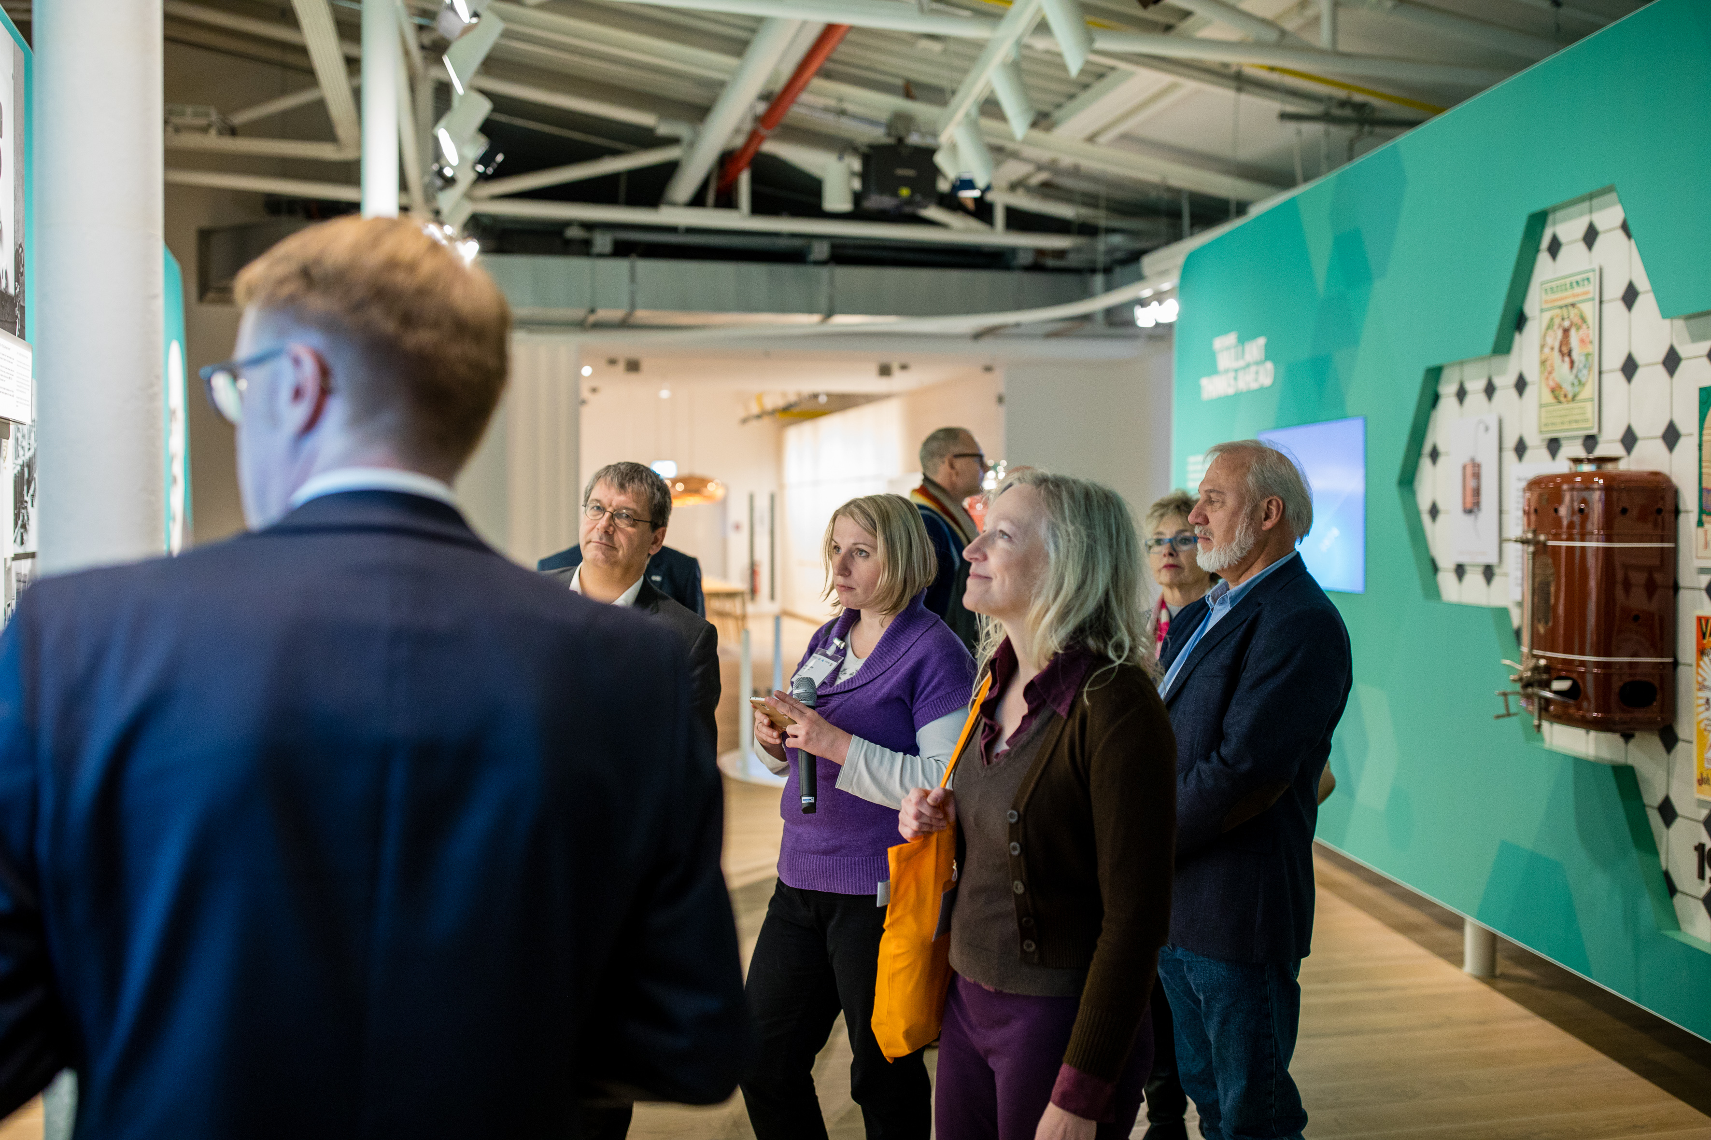

Caption: Attendees of the World Climate Conference familiarise themselves with sustainable, efficient heating technologies at the Vaillant Group.

Image: Vaillant Group

