Change in the Vaillant Group Management Board

- Dr Stefan Borchers appointed new Managing Director Finance and Services
- Dr Dietmar Meister is leaving the Vaillant Group at his own request after
successful work

Remscheid, 15 December 2017 – The Supervisory Board of Vaillant GmbH has appointed Dr Stefan Borchers a Managing Director of the heating, ventilation and air-conditioning specialist with effect from 1 January 2018. He will take over as successor to Dr Dietmar Meister the Group-wide responsibility for the Finance and Services divisions.

Dr Stephan Borchers was born in Hildesheim on 3 May 1969. Having studied Business Administration, Dr Borchers worked initially as research associate at the Technical University Brunswick and obtained his doctorate in the field of Controlling. In 2000 he joined Deutsche Lufthansa AG and worked there in the Shareholdings Management/M&A division. Two years later, Dr Borchers switched to the Bayer corporation. Following work in managerial positions in Germany and South America, he took over in August 2010 the position of Vice President Global Accounting at Bayer Material Science in Leverkusen. He joined the Vaillant Group on 1 May 2012 as Group Finance Director. Dr Borchers is married and has two sons.
Dr Dietmar Meister is leaving the Vaillant Group after successful work

After more than eight years work for the Vaillant Group, Dr Dietmar Meister has decided not to renew his expiring contract. So he will leave the company at his own request.

Dr Meister has since 2009 made a decisive input to the Vaillant Group in his function as Managing Director Finance and Services and contributed significantly to the company’s good development. He has rendered great services to the Vaillant Group.

The Supervisory Board thanks Dr Meister very much for his successful work and wishes him all the best for his personal and professional future.

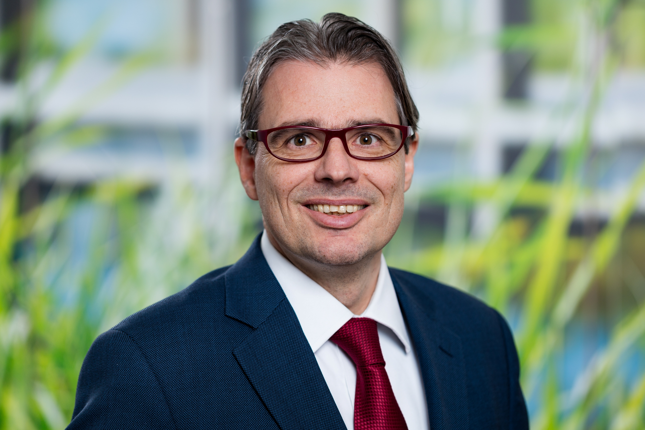

Picture caption: Dr Stefan Borchers will from 1 January 2018 as a Managing Director take over the Group-wide responsibility for the Finance and Services divisions at the heating, ventilation and air-conditioning specialist Vaillant Group.

Picture source: Vaillant Group

The Vaillant Group is an internationally operating heating, ventilation and air-conditioning technology concern based in Remscheid, Germany. As one of the world's market and technology leaders, the Vaillant Group develops and produces tailor-made products, systems and services for domestic comfort. The product portfolio ranges from efficient heating appliances based on customary fuels to system solutions for using regenerative energy sources. In financial year 2016 the company, which has been family-owned since its founding in 1874, achieved with more than 12,000 employees sales totalling €2.4 billion.
-------------------------------------------------------------------------------------------------------------
Contact

Dr Jens Wichtermann Phone: +49 2191 18-2754
Director Corporate Communications, Mobile: +49 175 2951810
Sustainability Management & Politics E-mail: jens.wichtermann@vaillant-group.com

Vaillant Group Web: www.vaillant-group.com

42850 Remscheid
Germany

