Dr Andree Groos to take over as Managing Director for Vaillant Group Sales, Marketing and Service

- Dr Tillmann von Schroeter new Regional Director
Central Europe and Managing Director Vaillant Germany

Remscheid, 17 April 2015 – The Supervisory Board of Vaillant GmbH has appointed Dr Andree Groos as a Managing Director of the heating, ventilation and climate technology specialist with effect from 1 October 2015. Dr Groos will take over Group-wide responsibility for Sales, Marketing and Service from Dr Carsten Voigtländer, who has led these divisions since 2011 in addition to his tasks as CEO. Dr Voigtländer will in future concentrate even more strongly on the further development and implementation of the corporate strategy and the central company divisions for which he is responsible. With this step, the Management Board will as planned consist of four members in future.

Until he assumes his new position Dr Groos will continue to carry out his tasks as Regional Director Sales, Marketing and Service Central Europe and Managing Director Vaillant Germany. In his current area of responsibility, Dr Groos will on 1 October 2015 be succeeded by Dr Tillmann von Schroeter, who to date has been responsible as Regional Director Sales, Marketing and Service for the Eastern European markets of the Vaillant Group.

Dr Andree Groos was born in Siegen, in North-Rhine Westphalia, on 3 December 1973. Having studied Business Administration in Rostock and Fontainebleau and obtained his doctorate in Innsbruck, he began his professional career in 2002 as Assistant to the Vaillant Group Management Board. In 2004 he took over as head of Group-wide Quality Management. In 2007 the economics graduate switched to the Marketing Department. There he held various managerial positions before he was appointed Managing Director of Vaillant Germany in May 2009. Since September 2010 Dr Groos has in addition to this task been Regional Director of the Vaillant Group’s Sales, Marketing and Service activities in Central Europe. Dr Groos is married and has three children.

His successor as Regional Director Sales, Marketing and Service Central Europe and Managing Director Vaillant Germany, Dr Tillmann von Schroeter, has worked in various managerial positions at the Vaillant Group since 2006. Before he assumed responsibility for Sales, Marketing and Service in the Eastern European markets at the beginning of 2013, Dr von Schroeter led the Strategy Department and from 2011 the company’s Central Marketing. Dr Tillmann von Schroeter is 42, married and has four children.

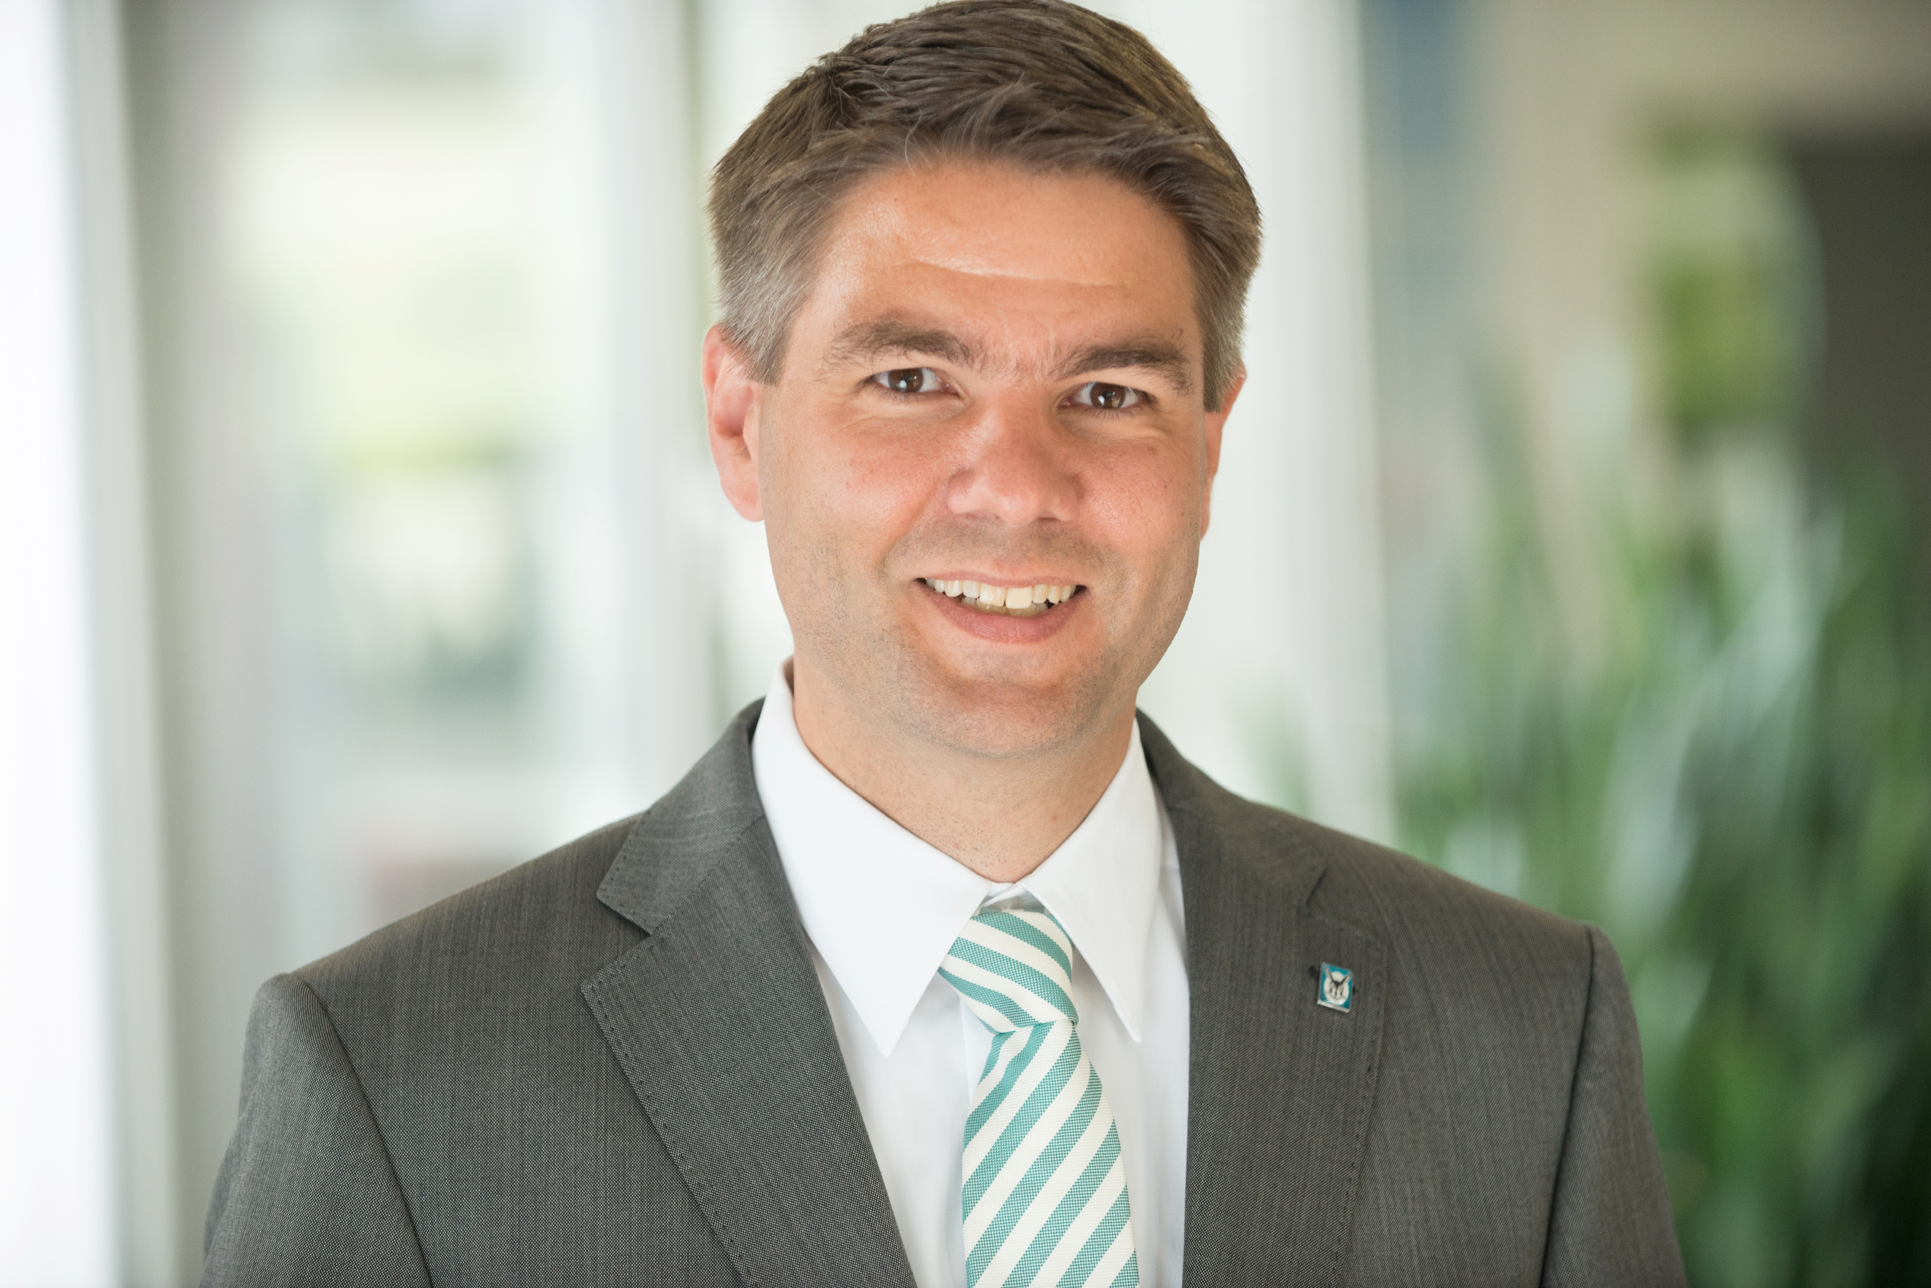

Caption: Dr Andree Groos takes over Group-wide responsibility for Sales, Marketing and Service as Managing Director of the heating, ventilation and climate technology specialist Vaillant Group from 1 October 2015.

Source: Vaillant Group

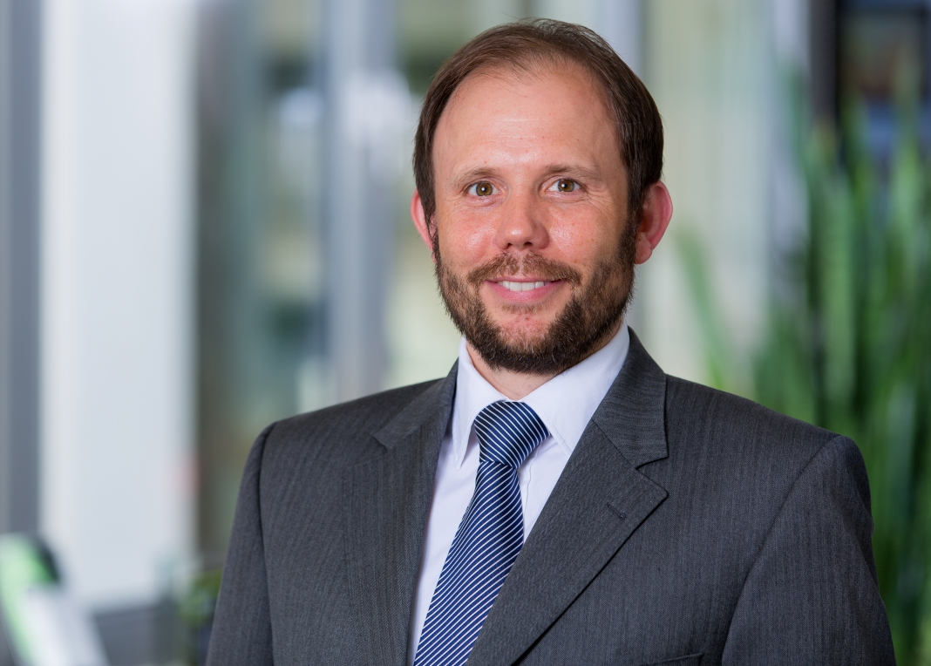

Caption: Dr Tillmann von Schroeter assumes the position of Regional Director Sales, Marketing and Service Central Europe and Managing Director Vaillant Germany.

Source: Vaillant Group

The Vaillant Group is an internationally operating heating, ventilation and climate technology company based in Remscheid, Germany. As one of the world's market and technology leaders, the Vaillant Group develops and produces tailor-made products, systems and services for domestic comfort. The product portfolio ranges from efficient heating appliances based on customary fuels to system solutions for using regenerative energy sources. In financial year 2013 the company, which has been family-owned since its founding in 1874, achieved with more than 12,000 employees sales totalling about €2.4 billion.
-------------------------------------------------------------------------------------------------------------
Contact

Dr Jens Wichtermann Phone: +49 (0)2191 18-2754
Director Corporate Communications, Mobile: +49 (0)175 295 18 10

Sustainability Management & Politics e-mail: jens.wichtermann@vaillant.de

Vaillant Group Web: www.vaillant-group.com

D-42850 Remscheid

